A short note in comparing a series and an integral
Kwok Choy YUE
L.H.Ma, an old boy of Queen’s College, sent me an infinite series and an improper integral:
1. $G=1+\frac{1}{3}+{\left(\frac{1}{3}\right)}^{2}+{\left(\frac{1}{3}\right)}^{3}+…=\frac{1}{1-\frac{1}{3}}=\frac{3}{2}=1.5$
2. $I=\int_{0}^{+∞}{{\left(\frac{1}{3}\right)}^{x}dx=}{\left[\frac{3^{-x}}{ln3}\right]}_{0}^{+∞}=\frac{1}{ln3}≈0.910$
The question : Why the value of the infinite geometric series, G, is bigger than the value of the improper integral, I.
In the first glance, G gives the sum of infinite vertical length on the curve $y={\left(\frac{1}{3}\right)}^{x}$, whereas I gives the area under the same curve, and the value of length cannot be compared with area.

However, if we change the infinite series G by multiplying a unit width to each term:
$$G=1+\frac{1}{3}+{\left(\frac{1}{3}\right)}^{2}+{\left(\frac{1}{3}\right)}^{3}+…=1×1+\frac{1}{3}×1+{\left(\frac{1}{3}\right)}^{2}×1+{\left(\frac{1}{3}\right)}^{3}×1+…$$
We can then get the sum of the rectangles as in the following curve:

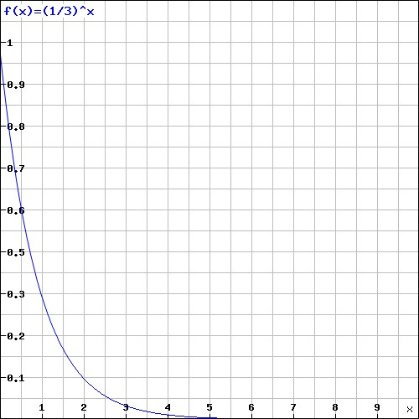

Obviously, the sum of the area of the infinite rectangles, or the Darboux upper sum, is greater than the area under the given curve. If we put away the first term of G, we get
$g=\frac{1}{3}+{\left(\frac{1}{3}\right)}^{2}+{\left(\frac{1}{3}\right)}^{3}+…$. I hope that now you can then draw the Darboux lower sum and we can get easily : g < I < G .

